**Sprint-3**

|  |  |
| --- | --- |
| Team ID | PNT2022TMID52274 |
| Project | Smart waste management system for metropolitan cities |

SCREENSHOTS FOR IBM CLOUD SIMULATORS:

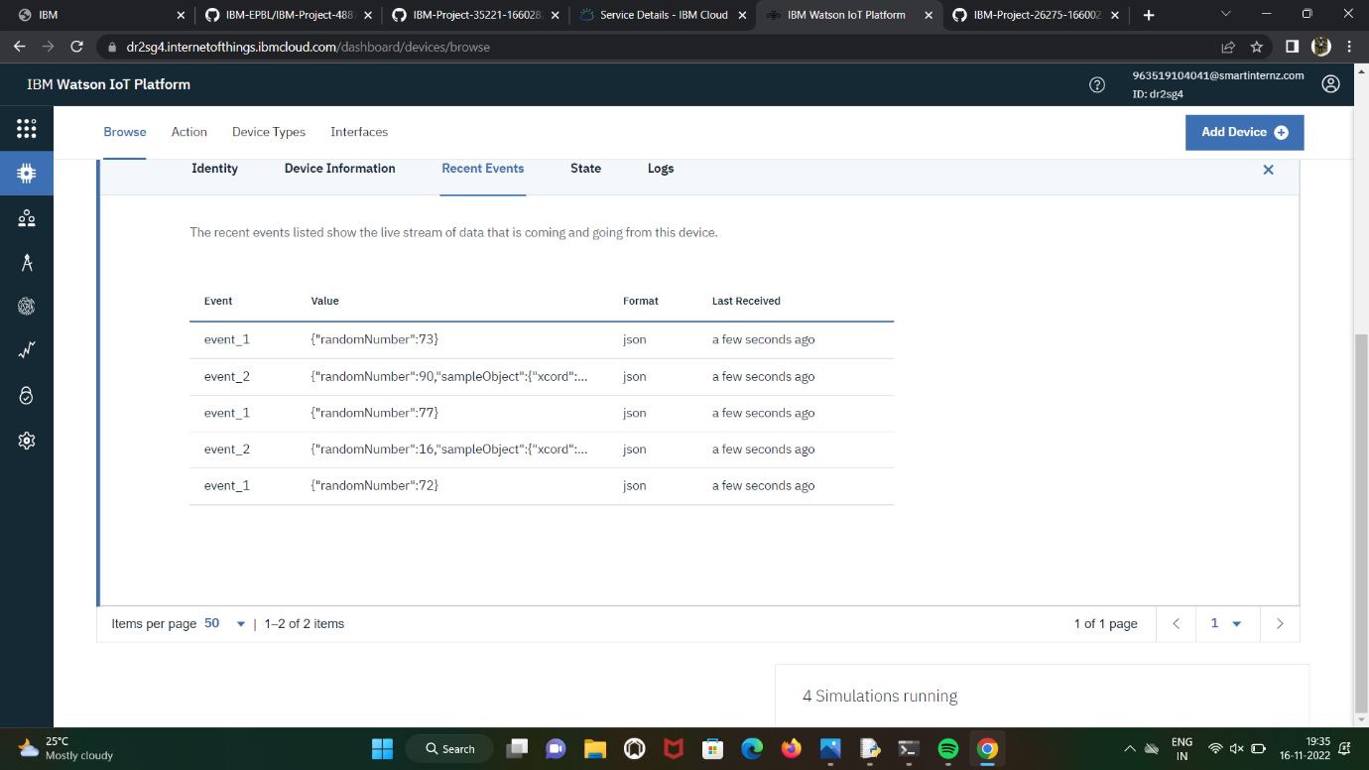

PNT2022TMID52274

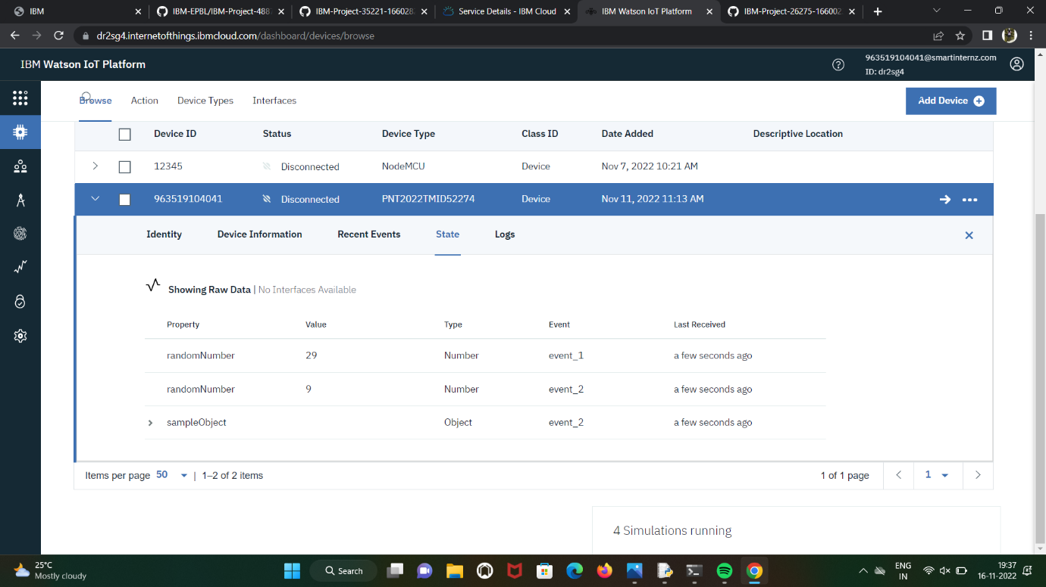

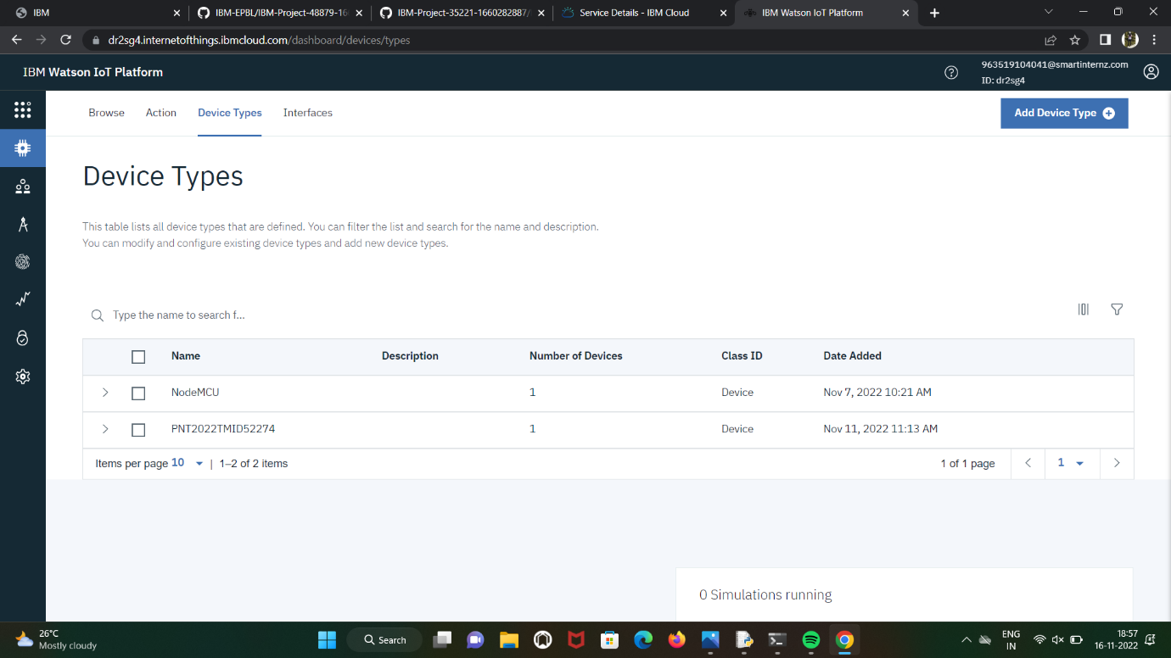

PNT2022TMID52274

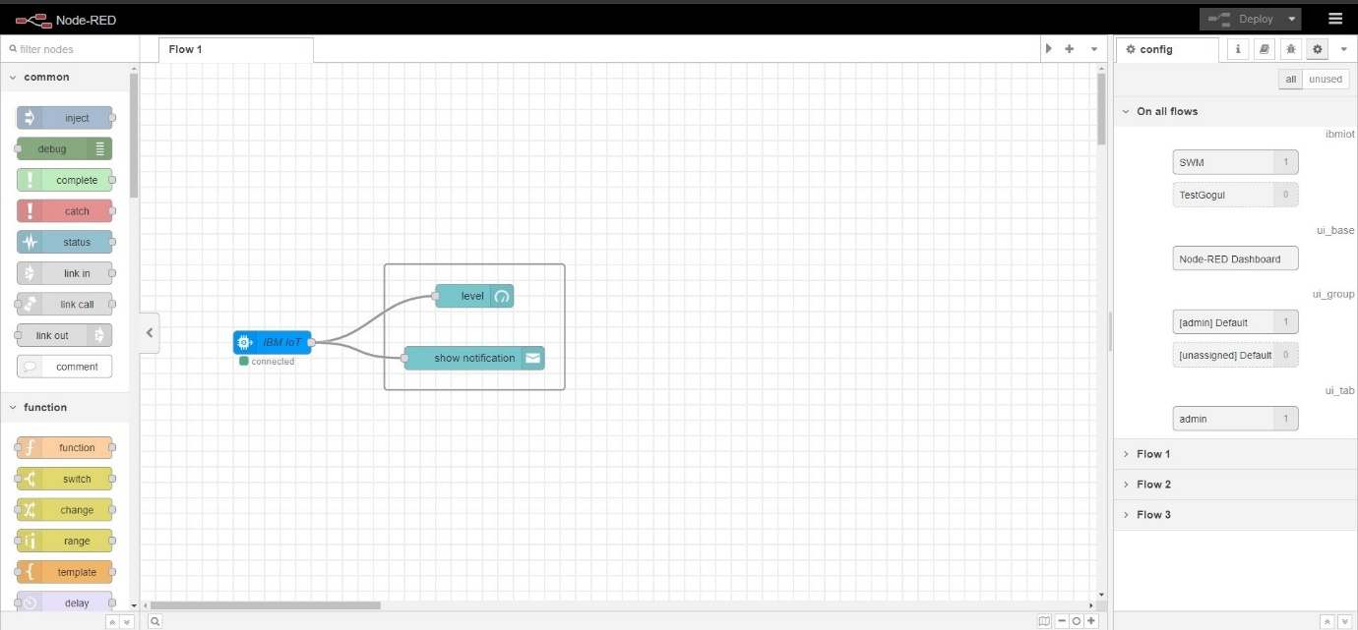

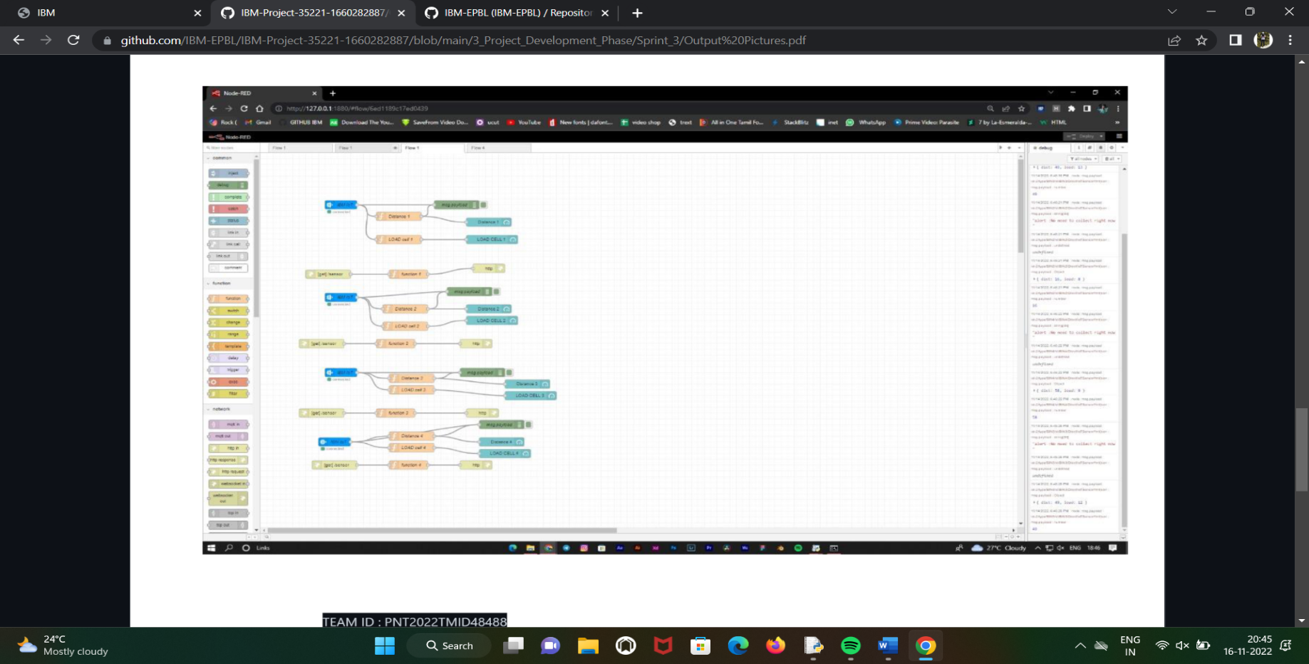

PNT2022TMID52274